**Room Booking – Mobile**

Download “Adappt booking” app from playstore and install.

Open the App and Enter Company Name

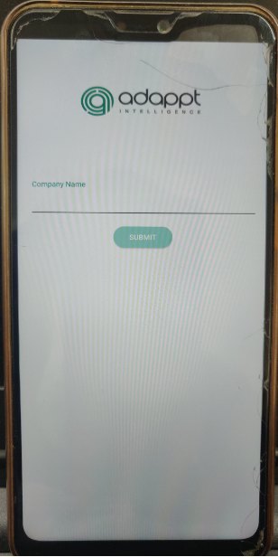

Enter Credentials

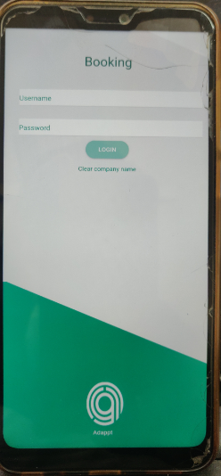

**Home Page will be displayed**

**If User is already Registered and Try to book again , Home screen will be displayed**

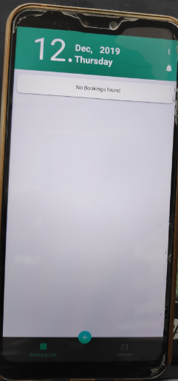

Using “ + “ Mark and select SEAT

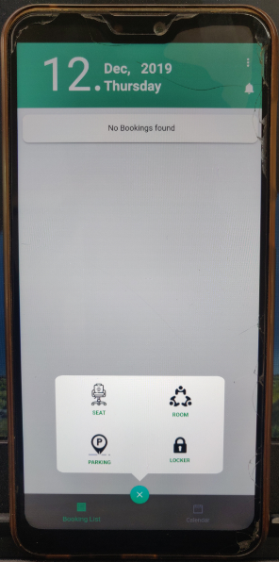

**As User is new profile settings are required, click continue and enter required details and press “save settings”. Settings will be saved successfully**

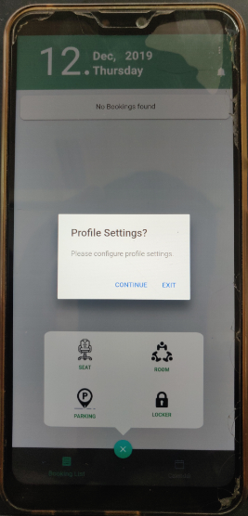

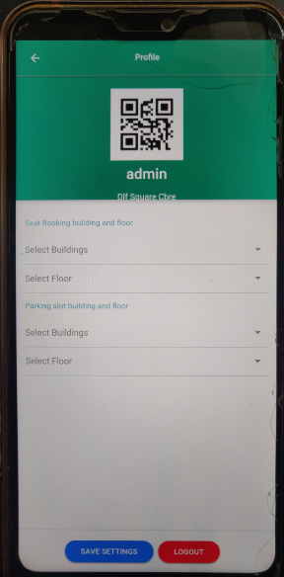

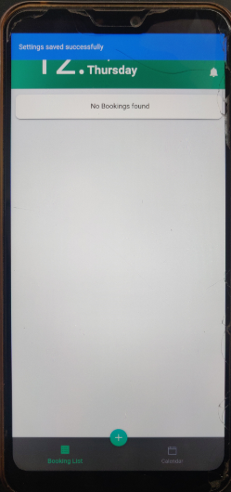

**ROOM Booking Flow**

Now Select Seat from “+”

Select Location/ROOM and Required Parameters , then confirm to Book.

App Notification will be showed 10 mins before booking starts

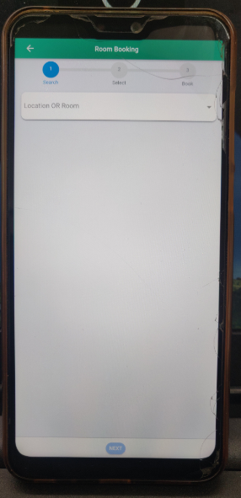

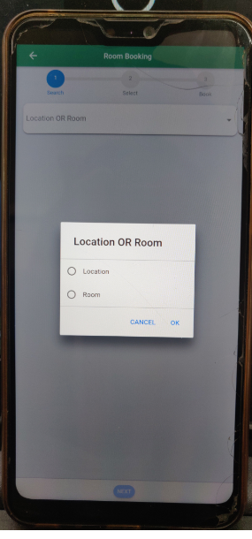

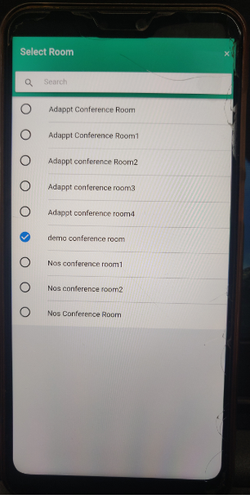

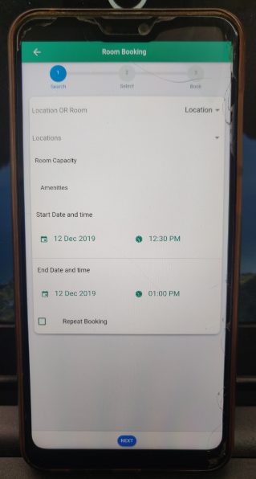

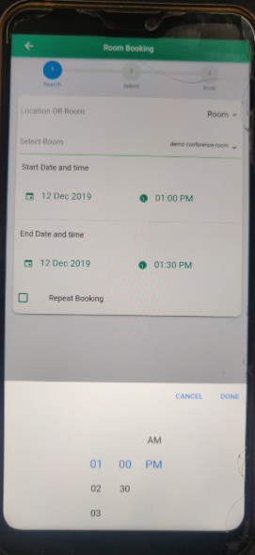

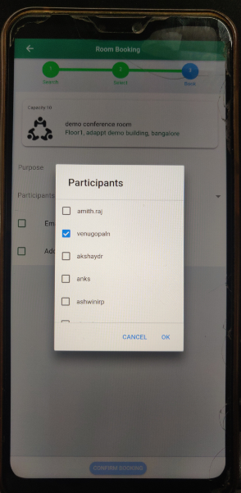

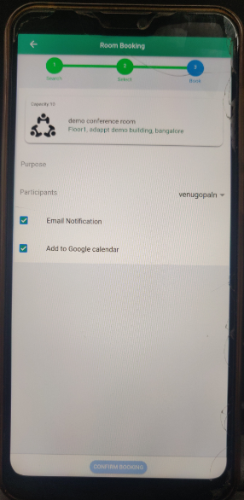

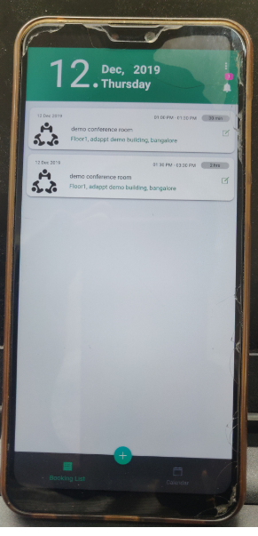

**If Attendee has a meeting already in the same time , warning message will be shown**

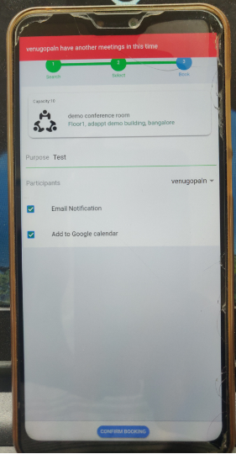

**Update Booking**

**S**elect EDIT Symbol on the Room Booking info.

Select required Parameters then Update and confirm

App Notification will be showed 10 mins before booking starts

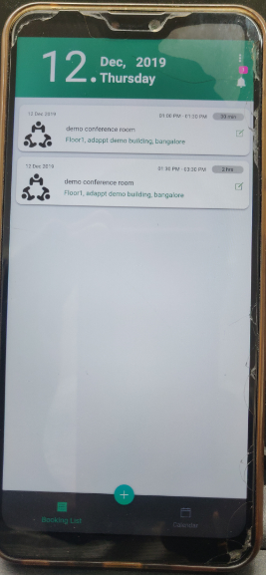

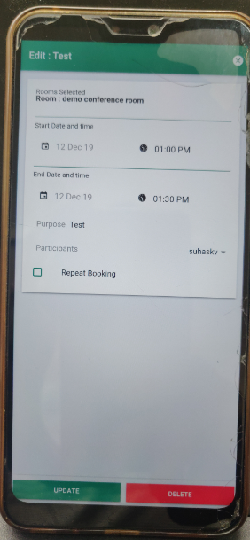

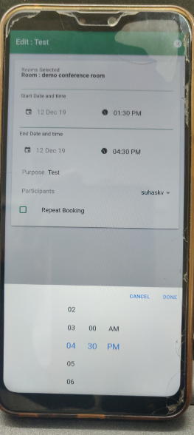

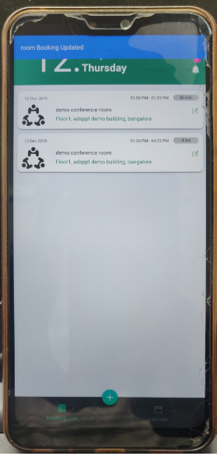

**To Cancel the Booked ROOM**

**S**elect EDIT Symbol on the Booking info.

Select DELETE , Then choose DELETE

Booking cancellation message will be displayed

App notification will be shown.

